**Sampling theorem**

The sampling theorem specifies the minimum-sampling rate at which a continuous-time signal needs to be uniformly sampled so that the original signal can be completely recovered or reconstructed by these samples alone.

**Sampling theorem:**

If a [continuous time signal](https://www.sciencedirect.com/topics/engineering/continuous-time-signal) contains no [frequency components higher](https://www.sciencedirect.com/topics/engineering/high-frequency-component) than *W* hz, then it can be completely determined by uniform samples taken at a rate *f*s samples per second where

fs≥2W

or, in term of the sampling period

T≤12W

A signal with no frequency component above a certain maximum frequency is known as a bandlimited signal. Figure 2.4 shows two typical bandlimited signal spectra: one low-pass and one band-pass.

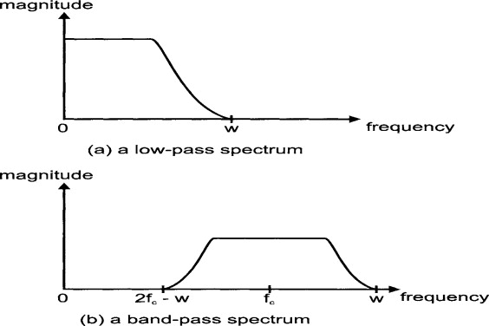

The Sampling Theorem

The sampling theorem is an important aid in the design and analysis of communication systems involving the use of continuous time functions of [finite bandwidth](https://www.sciencedirect.com/topics/engineering/finite-bandwidth). The [theorem states](https://www.sciencedirect.com/topics/engineering/theorem-state) that, if a function of time, *f*(*t*), contains no frequencies of *W* hertz or higher, then it is completely determined by giving the value of the function at a series of points spaced (2*W*)−1 seconds apart. The sampling rate of 2*W* samples per second is called the *[Nyquist rate](https://www.sciencedirect.com/topics/engineering/nyquist-rate" \o "Learn more about Nyquist rate from ScienceDirect's AI-generated Topic Pages)*.

If *f*(*t*) contains no frequencies of *W* hertz or higher, then it can be recovered from its samples by the Nyquist-Shannon interpolation formula:

f(t)=∑n=−∞+∞f(n/2W){[sin π(2Wt−n)]/π(2Wt−n)}

The sampling theorem makes no mention of the time origin of the samples; it is only the spacing of the samples that matters.

If function *f*(*t*) is negligible in magnitude outside a time interval *T* and has negligible energy at frequencies higher than *W* hertz, it can be specified by 2*TW* ordinates. If a [Gaussian noise](https://www.sciencedirect.com/topics/engineering/gaussian-white-noise) process with rectangular spectrum is sampled at the [Nyquist](https://www.sciencedirect.com/topics/engineering/nyquist-frequency" \o "Learn more about Nyquist from ScienceDirect's AI-generated Topic Pages) rate, the samples are independent.